Advertise with us at Restored Treasures
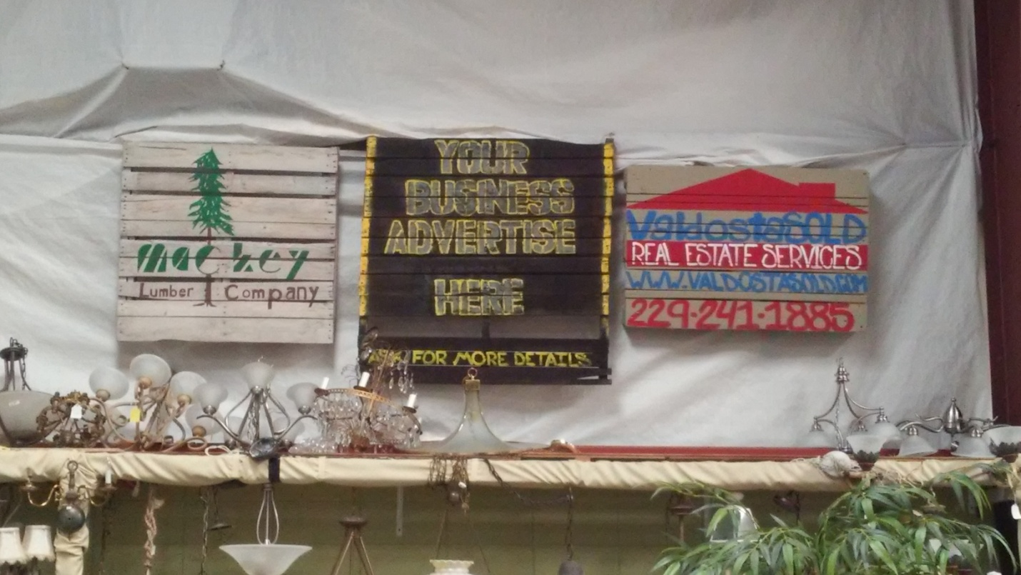
People will notice your business right when they walk in the doors.
We can put your logo on one of our pallets.
For just $75, your business will stay on our wall and people will know you’re supporting a great cause, here at Restored Treasures Upscale Thrift Store.
For more information email mtrestoredtreasuresga@gmail.com or call the store 229-242-8371

Advertise with us at Restored Treasures
Restored Treasures “Advertise with us” program allows local businesses to advertise their business/product logo with us. We build the pallet and paint your logo. The pallet will be displayed on the wall in our store. The charge is a onetime non-refundable cost of $75.00 and includes the pallet, the art and the placement of pallet. The customer is required to provide a logo outline and direction at the time of payment ($75.00). Restored Treasures has the right to position the pallet in their store. The pallet will stay up as long as the customer chooses and as long as Restored Treasures is still running the “Advertise with us” promotion. Restored Treasures has the right to use needed materials/media to build and paint the pallet. If the customer is not satisfied with the outcome of the pallet they may have it redone one time at no cost. By signing at the bottom of this page you agree to the terms of this contract. Thank you for choosing Restored Treasures and have a blessed day.
Print name____________________________________
Sign _________________________________________
Date ___/___/___
Form of payment _______________

